Wispr Lite — Quick Guide
Hold Right Ctrl, speak, release — your words are typed for you.

Getting Started
Double-click WisprLite.exe. No installation needed. A tray icon appears near the clock (click the ^ arrow if you don't see it).
 | Loading the speech model (first launch only, needs internet)
 | Ready — hold Right Ctrl to dictate
 | Recording — listening to you

How to Dictate
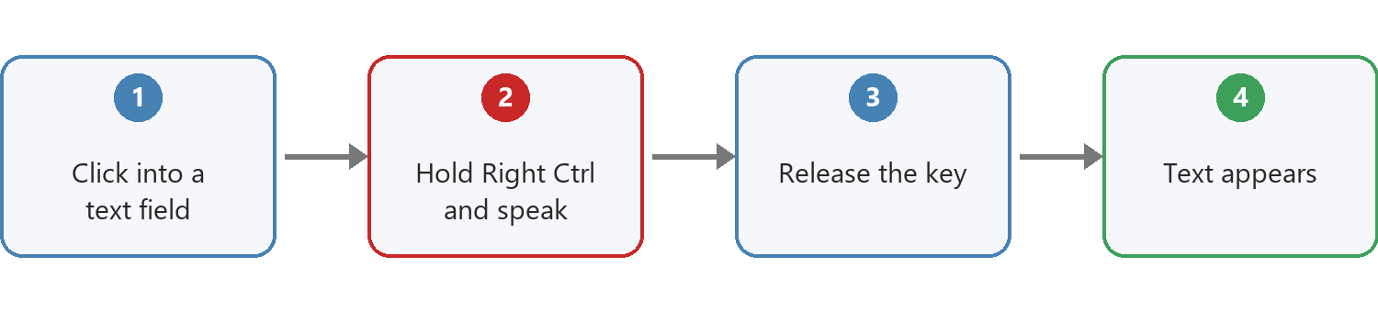
If you say the wrong thing, just correct yourself out loud — e.g. "Send it tomorrow, no wait, send it Friday" — and only the corrected version gets typed. Works with phrases like "scratch that", "no wait", "sorry, I mean".

First-Run Security Warnings
Since this isn't a signed, store-published app, Windows may show "Windows protected your PC." Click More info, then Run anyway. Some antivirus tools may also flag it — this is a known false-positive for this type of packaged app, not a sign of anything malicious.

Removing the App
Delete WisprLite.exe — that's the whole app, nothing else is installed.
To also remove the downloaded speech model (about 500 MB), delete this folder:
%USERPROFILE%\.cache\huggingface\hub\models--Systran--faster-whisper-small.en

Good to Know
- Windows only. Uses your default microphone.
- All speech processing happens locally on your PC — nothing is sent anywhere.
- Works in most apps (browsers, Word, chat apps, WhatsApp). A few custom-drawn text boxes may not be detected — you'll see a popup reminding you to click into a text field.

